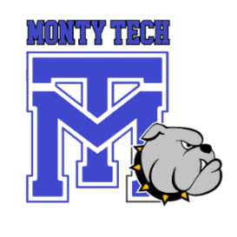

Montachusett Regional Vocational Technical School

Program Advisory Committee Meeting

Wednesday, February 12, 2025

6:00 p.m. dinner in the School Cafeteria

Followed by Meetings in your Respective Shops

AGENDA

1. Welcome, Call to Order
2. Introduction of new members
3. Attendance and update contact info
4. PAC Recruitment
   1. Review DESE representation requirements
5. Review SY 2025-2026 requested budget
6. Review exploratory results
7. Review/ Update five-year plan (as needed)
   1. Proposed new equipment/ software/ technology purchases
8. Review and discuss Perkins V Survey results from Fall Advisory Meeting
   1. Discuss potential improvements
   2. Areas that scored lower than expected, and why
9. Complete Programmatic Review
10. Coop Numbers
    1. Companies hiring Coop students
11. Additional Items per Chair and Facilitator